A139-Eur- Moravia-Střelice-Figurine**-**Female-Ceramic-4,850-4,450 BCE

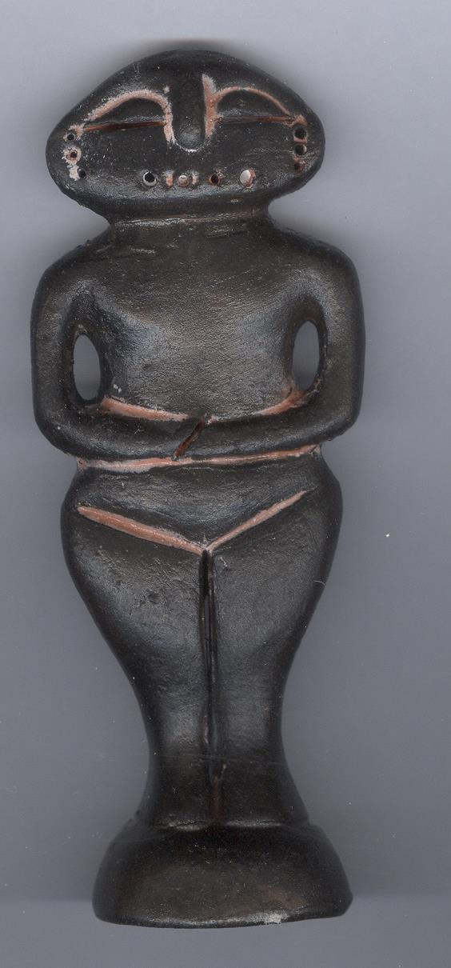

Fig. 1. Czech Republic-Moravia-Střelice-Figurine**-**Female-Ceramic

Case No.: 1

### ****Formal Label:**** Czech Republic-Moravia-Střelice-Figurine-Female- Ceramic

**Display Description:** Střelice Moravian ceramic figurines, such as this one, were located in the context of habitations (notably near hearths, see Sázelová 2008) in settled areas in large reoccupied sites near agricultural resources (Čižmář et alii 2008), which near this site is still being farmed today. This particular figurine displays a normal female physiogamy with wide hips, but no breasts and without an emphasis on corpulence. It also has earrings. Furthermore, it has been sculpted with a base. The figurine has also been colored with red ochre or cinnabar, usually the sign of life since blood is red also, of which some still adheres. It was probably set in a shrine for ritual purposes.

### ****Accession Number:**** A139

### LC Classification: GN772

**Date or Time Horizon:** 4,850 BCE-4,450 BCE

**Geographical Area:** Czech Republic, Moravia,Střelice

**Maps** from http://latitude.to/img/latitude-logo.svg; **GPS Coordinates:** 49.15694 16.50889;40° 26' 46" N 79° 58' 56" W

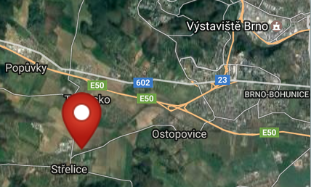 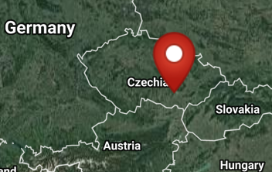

**Cultural Affiliation:** Neolithic

**Medium:** Fired clay.

**Dimensions: original, H** 22 cm (8.7 in).

**Weight: original, unknown.**

**Condition: Resin replica of original.**

**Provenance:** Czech Republic, Moravia,Střelice Museum.

**Discussion:** Střelice Moravian ceramic figurines, such as this one, were located in the context of habitations (notably near hearths, see Sázelová 2008) in settled areas in large reoccupied sites near agricultural resources (Čižmář et alii 2008), which near this site is still being farmed today. A very conservative figural grammar (Humpolová and Podborský 2013) was evidently sustained for many generations based on C14 data (Kuča 2012, 2011). Since this figurine is not broken it may have been placed outside a habitation in a ritual area when the houses were ritually burned and the household was moved and figurines inside were ritually broken.

**References:**

Čižmář, Zdeněk, ed*.* 2008. *Život a smrt v mladší době kamenné. Katalog výstavy. Leben und Tod in der Jungsteinzeit.* [Life and Death in the New Stone Age.] Brno:Ústav archeologické památkové péče ve spolupráci s Jihomoravskzm muzeem ve Znojmě a Moravským zemským muzeem v Brně.

Humpolová, Alena and Vladimír Podborský. 2013. *To nejlepší z archeologické sbírky Františka Vildomce.* [The Best of the Archaeological Collection of František Vildomec]. Brno: Moravské zemské muzeum.

Králík, Miroslav and Novotný, Vladimír. 2005. Dermatoglyphics of Ancient Ceramics. In: Svoboda Jiří, ed. *Pavlov I Southeast. A Window into the Gravettian Lifestyles*. Brno: Academy of Sciences of the Czech Republic, Institute of Archaeology, and Kraków: Polish Academy of Sciences, Institute of Systematics and Evolution of Animals, Chapter IV.5, pp. 449-430.

Kuča, Martin, Jan Josef Kovář, Miriam Nývltová Fišáková, Petr Škrdla, Lubomír Prokeš, Miroslav Vaškových, and Zdeněk Schenk. Chronologie neolitu na Moravě. Předběžné výsledky. 2012. [Chronology of the Moravian Neolithic. Preliminary results.] Přehled výzkumů, 53(1).

Kuča, Martin, Jan Josef Kovář, Miriam Nývltová Fišáková, Petr Škrdla, Lubomír Prokeš, Miroslav Vaškových, and Zdeněk Schenk. 2011. Chronologie neolitu na Moravě: Předběžné výsledky,” *Přehled výzkumů*, 53(1).

Sázelová, Sandra. 2008. “Female Figurines of Northern Eurasia: An Ethnological Approach.” In Svoboda, Jiří A., *Petřkovice. On Shouldered Points and Female Figurines.* The Dolní Věstonice Studies, Vol. 15, Brno: Academy of Sciences of the Czech Republic, Institute of Archaeology, pp. 224-232.

Svoboda, Jiri, Vojen Lozek, and Emanuel Vlcek. 1996. *Hunters between East and West, the Paleolithic of Moravia*. New York: Plenum Press; New York: Springer.